Sprint 1 Plan

Plan-it

Team Rocket

10/20/2019

Revision 1, 10/09/2019

**High Level Goal:**

*Create an intuitive user interface for easy data entry. Create buttons, text field entry, and window functionality, and bind to corresponding methods, even if the methods are not yet functional.*

User story 1: (0 story points)

As a developer, I want a runnable file so that the project can be run for testing. (Already Completed)

Total for user story 1: 0 Hours

User story 2: (5 story points)

As a user, I want an interface that allows me to input data into text fields and submit them to be stored, as well as a “generate activity plan” button, so I can easily interact with the application.

Resize windows based on screen size, and properly center text.

**Estimated time: 2 Hours**

When “Generate” button is pressed, open a new window.

**Estimated time: 0.5 Hours**

When “Current Activities” button is pressed, open a new window (like the one opened by the "Generate Activity Plan" Button.

**Estimated time: 0.5 Hours**

Display elements of PlanitRunner.database in a table, with the ability for the user to edit the fields.

**Estimated time: 6 Hours**

When the user clicks an "X" icon next to a given row, remove the given activity.

**Estimated time: 2 Hours**

When “Save Changes” button is pressed, update PlanitRunner.database with the new version of the table, after user has edited fields and/or removed activities. (Can replace database with new ArrayList<Activity>, or find a more efficient alternative if possible.

**Estimated time: 3 Hours**

Create dummy buttons for “Save Plan” and “Print Plan” features.

**Estimated time: 0.5 Hours**

Total for user story 2: **14.5 Hours**

User story 3: (5 story points)

As product owner/developer, I want the application to prompt and allow users to enter in activities they enjoy, along with the maximum length, ideal length, and maximum cost of each activity, so that these activities can become the basis of the user’s future activity plans.

When “Submit Activity” button is pressed, create a new Activity() and set .name, .maxTime, .idealTime, and .maxCost properties of the Activity based on user input to fields, and adds the activity to PlanitRunner.database. (Plus exception handling).

**Estimated time: 6 hours**

Display the list of activities generated by the Plan.generatePlan() algorithm (not yet written). Can use a temporary algorithm that generates a set list of activities for testing instead.

**Estimated time: 2 hours**

Calculate/display the total time and total cost of the selected ArrayList<Activity> at the bottom.

**Estimated time: 1 hour**

Total for user story 3: **9 Hours**

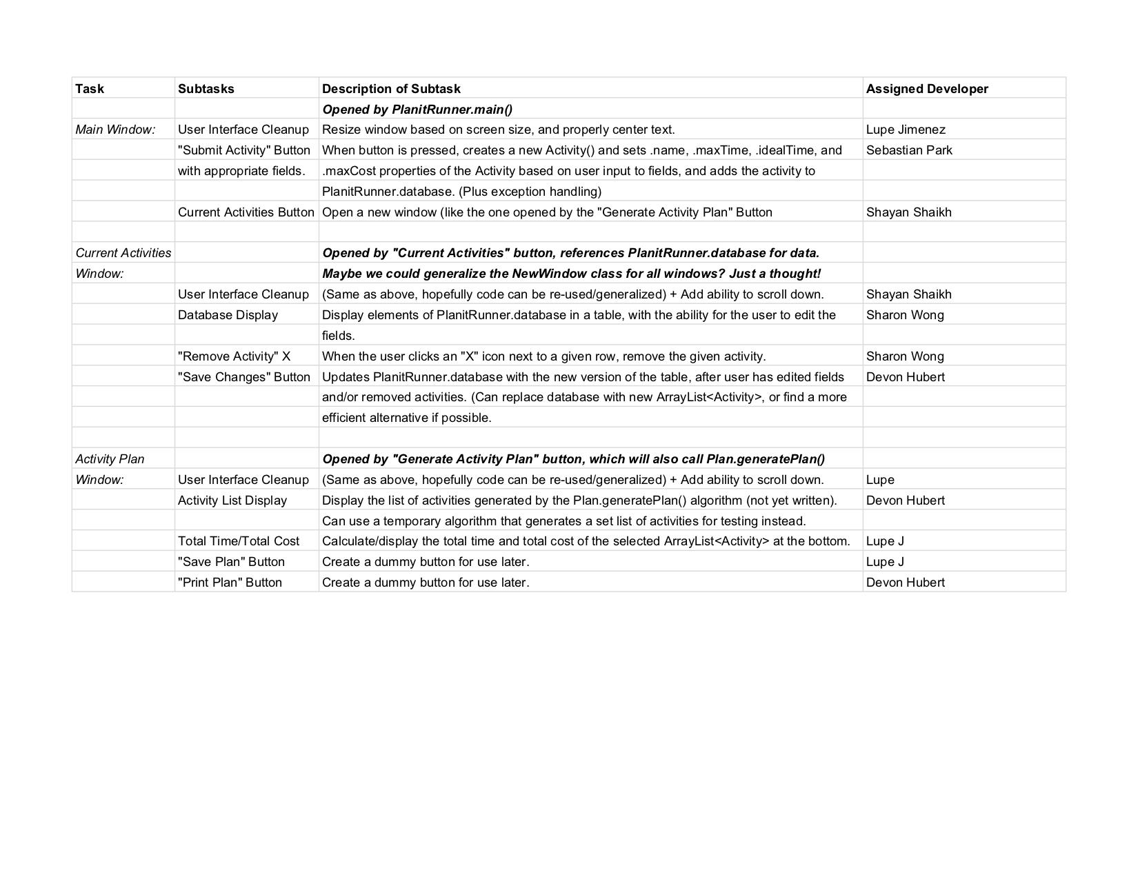

Meeting times: Monday, Wednesday, and Friday at 11:30. TA meeting on Wednesdays at 10:30 in room 316.